Sangala Studio
User Guide

A Computer Assisted Design (CAD) Program
For Creation of 2D and 3D Models for the Classroom
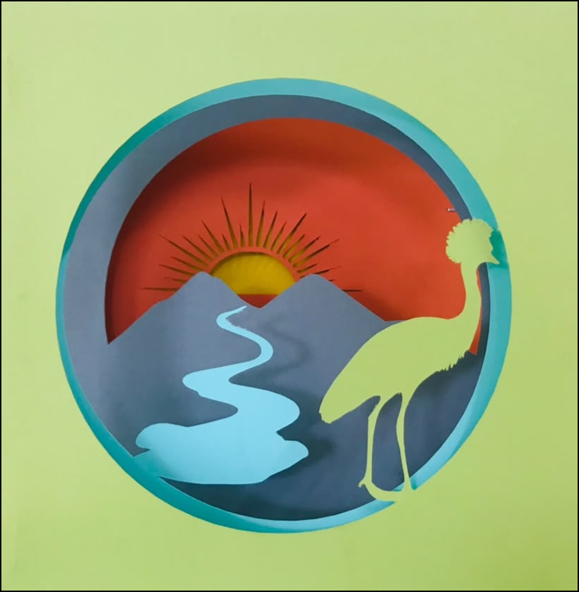

Glen Bull, Jo Watts and Moses Kumenya
Table of Contents
Part 1. Two-dimensional Design Tools 2
1. Workflow for Creating a Collage 2
2. Getting started 2
3. Cut lines and fold lines 3
4. Importing and tracing a photo 4
5. Drawing shapes 5
6. Editing shapes 6
7. Drawing with Snap! 7
8. Combining shapes 10
9. Aligning shapes 10
10. Mirroring shapes 11
11. Examining Fine Detail 11
12. Cutting Out a Design 11
13. Saving the Design 12
Part 2. Three-dimensional Design Tools 14
14. Designing in 3D 14
15. Switching to 3D 14
16. Giving a shape depth 14
17. Sloping a top 15
18. The Part tool 16
19. Previewing in 3D 17
20. Marking a Shape as a Hole or a Guide 18
21. 3D bars 19
22. Grouping pieces 19
23. Combining in 3D 20
24. Seeing a hole before you combine 21
25. Building a curved, tapering part 21
26. Saving for the 3D Printer 21
Part 3. From a Mosaic to a Printed Figure 22
27. Opening a mosaic 22
28. The Parts panel 23
29. Planes 24
30. Setting a relief 25
31. Mirroring a plane 26
32. Exporting a figure in pieces 26
Part 4. From a Brick Figure to a Printed Figure 28
33. Opening a brick figure 28
34. What a brick carries across 28
35. Named elements become planes 28
Appendix A. Installing Sangala Studio 29
Appendix B. Quick Reference 30
Appendix C. Tool Sequences for Specific Designs 32
Appendix D. Drawing with TurtleStitch 33

Introduction
Sangala Studio is a Digital Fabrication tool developed to support the course, Introduction to Design through Making. The word "sangala" means joy in the Lugisu language spoken in the Mt. Elgon region in East Africa. A version of this course focused on exploring art and engineering is being developed to support a collaboration with East Africa. A book, Design through Making: Art and Engineering, has also been developed to support this special version of the course. It focuses on a sequence of activities that move from two-dimensional art to three-dimensional design and then incorporate animated and automated mechanisms.
These activities have been developed over sixteen years. They began in 2010 with the construction of the Laboratory School for Advanced Manufacturing, a joint project of the Charlottesville City School System and the University of Virginia, led by the faculty and staff of the Make to Learn Laboratory. They continue to be developed through a collaboration between the University of Virginia and REACH for Uganda, anchored by EDIS 3050 at the University of Virginia and a pilot course at Hawthorne-Scribner High School.
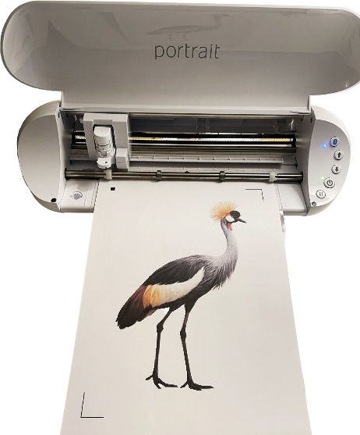
Figure 1. Using Sangala Studio and a Silhouette die cutter to cut out the silhouette of a crested crane.
The Sangala Studio digital fabrication tool supports the design activities in the 2D design portion of the course covered in Chapters 1 through 3 of the accompanying book. These activities include development of a collage that is used as scaffolding to create a shadowbox. A shape designed in Sangala Studio is fabricated on a digital die cutter. This guide covers the 2D features needed for these projects: importing and tracing a photo, drawing and combining shapes, and doing a print-and-cut. The final section introduces the three-dimensional design mode, which is used later in the course for objects made on a 3D printer.
Sangala Studio must be installed on the computer before these tools can be used. Appendix A describes where to obtain it and how to install it.

Part 1. Two-dimensional Design Tools

1. Workflow for Creating a Collage
To make a collage, the workflow follows this sequence using Sangala Studio:
- Identify an image.
- Import the image into Sangala Studio.
- Remove the background.
- Use the outline of the image as the template for an object in the collage.
- Send the outline to the digital die cutter to cut out the shape from cardstock.
The pieces can be cut one at a time from colored cardstock, as in step 5 above. They can also be finished together: give each piece a paper color, arrange them on the page, and print the whole collage in color on a single sheet of white cardstock. The die cutter then cuts every piece out in one pass (Section 11).
The following sections describe the tools in Sangala Studio used to fabricate the collage.

2. Getting started
Sangala Studio runs in a web browser and controls the die cutter — the machine that cuts a shape by tracing its outline with a small blade. The window has three parts:
- The mat in the center of the Sangala Studio workspace is the large white rectangle. It represents the sticky carrier sheet — the physical sheet that holds the paper flat and carries it through the die cutter. Cardstock or paper placed on the mat is what the machine will cut.
- The Tools Palette runs down the left edge. Each button is one tool for drawing or editing shapes.
- The Fabricate Panel on the right holds the green Make It! button, short status messages, and — whenever a shape is selected — a panel for changing that shape.
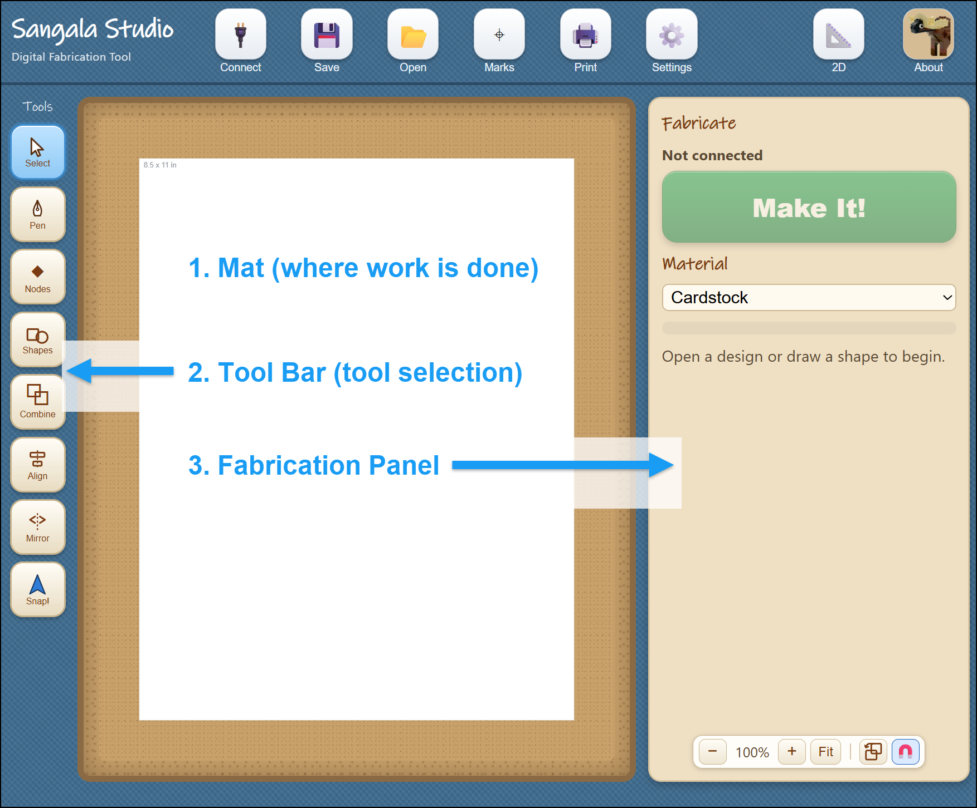
Figure 2. The Sangala Studio window, with (1) the Mat in the center,
(2) the Tools Palette on the left, and (3) the Fabricate Panel on the right.
To use the die cutter, first connect to it:
- Plug the die cutter into the computer with its USB cable and turn it on.
- Click the Connect icon at the top left.
- When the status in the Fabricate Panel changes from "Not connected" to the machine's name (Silhouette Portrait 3 in this instance), Sangala Studio is ready to fabricate shapes.
A design can be made at any time; a connection to the die cutter is only needed to cut out a shape.
The top row also carries the controls for keeping a design. The Save button (the disk icon) sits between Connect and Open, and clicking it opens a small menu with two choices — Save as SVG and Save project, described in Section 13. In 3D mode an Export STL button (the blue diamond) appears on this same row for saving a model to print; it stays hidden while a design is being cut out.

3. Cut lines and fold lines
The die cutter treats a line in one of two ways, and it cannot tell them apart on its own, so each line must be marked. There are three kinds:
- Cut Lines — the blade cuts all the way through the cardstock. A cut line is a solid red line.
- Fold Lines — The die cutter makes a series of dashed cuts to create a crease (fold line) so that the cardstock folds cleanly along it. A fold line is a dashed blue line.
- Print Only — Shapes and images can be printed on an inkjet printer. This is used for artwork or shapes.
In the illustration below (Figure 3), a calibration card developed as a test file is shown with a cut line (a solid red line) around the perimeter of the card and a fold line (shown as a dashed blue line) in the center of the card.
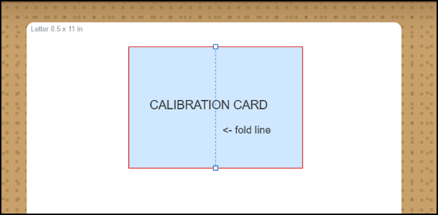
Figure 3. A cut line is shown in red while a fold line (in the center) is a dashed blue line.
The die cutting machine will create dashed scores in the center of the card so that it can be folded and will cut out the card from the cardstock using the solid red line as a guide that determines the path of the cutting blade.

4. Importing and tracing a photo
Sangala Studio can turn a photograph into a silhouette — the solid outline of a subject with all its inner detail removed, such as the shape of a crowned crane standing black against the page.
- Click Open (the Folder Icon) and choose a photograph (a .png or .jpg file). It appears on the mat as a reference layer.
- Click Remove BG (the Wand Icon). Sangala Studio attempts to find the main subject in the foreground. It then draws a red line around the outline of the object. This outline is the path that the blade will follow to cut out the silhouette of the object.
- Use the two sliders that appear in the Fabricate Panel to make adjustments:
  - Silhouette Threshold makes the outline tighter or looser.
  - Ignore Specks removes small stray bits so that only the main subject is outlined.
- Click Confirm. Sangala Studio removes the background outside of the red cut line, leaving the subject and the red path the blade will follow around it.
- There are two options at this point:
    - To simply create a silhouette of the object from colored cardstock,
      - Place the cardstock on the carrier sheet and load it into the die cutter.
      - Then click the Make It! button on the Fabricate Panel to cut out the silhouette.
    - To print the image and cut it out of the printed card stock:
      - First turn registration Marks on. Three marks appear on the page; the die cutter reads them to line the blade up with the printed picture.
      - Then click Print to send the image (with registration marks) to print the picture on an inkjet printer.
      - Next place the printed cardstock on the carrier sheet and load it into the die cutter.
      - Finally, click the Make It! button on the Fabricate Panel to cut out the image.
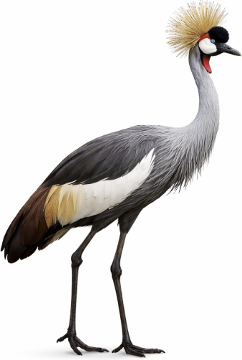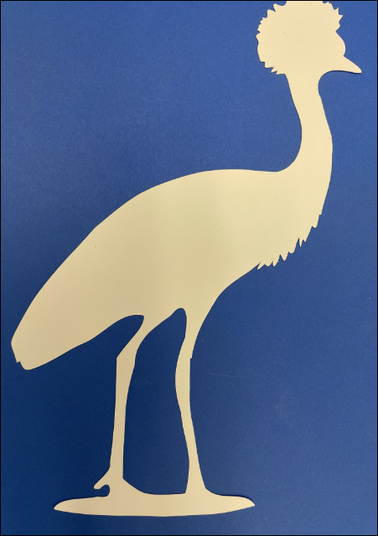
Figure 4. A photograph of a crane (left) and its silhouette cut out of cardstock (right).

5. Drawing shapes
Not every shape comes from a photo. Two tools draw shapes directly.
The Shapes tool (the rectangle-and-circle icon) opens a small menu:
- Click Shapes, then choose Line, Rectangle, or Circle.
- Drag the cursor across the mat. A rectangle grows from corner to corner; a circle grows from its center outward.
A line runs straight from where the drag starts to where it ends. Hold Shift to keep it level, upright, or at 45 degrees. A line is a Cut line at first — it slits the paper; click Fold to make it a crease instead.
- Release the mouse button to create a shape.
Note: To set an exact size, select the shape and type its measurements in the Selected Object panel (Section 6).
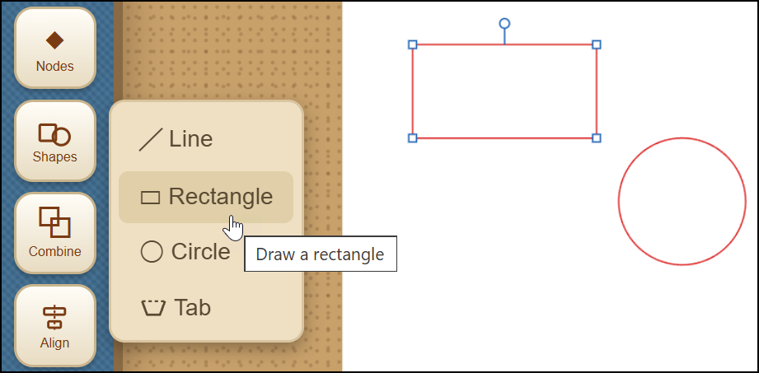
Figure 5. The Shapes menu (Line, Rectangle, Circle, Tab) and shapes drawn on the Mat workspace.
The Tab tool (also in the Shapes menu) adds a glue tab — the small flap that folds back and is glued when a flat design is assembled into a box or model:
- Click Shapes, then choose Tab.
- Press on the edge of a shape and drag along it. The stretch covered becomes the fold hinge, and a preview of the tab follows the drag.
- Release, and the tab is built: three cut sides, a fold hinge on the edge — and the shape's own edge beneath the hinge is removed automatically, so the tab stays attached instead of being cut off.
The tab's size is chosen automatically from the length of the hinge. Its pieces are grouped so the tab moves as one; use Ungroup to adjust a side by hand.
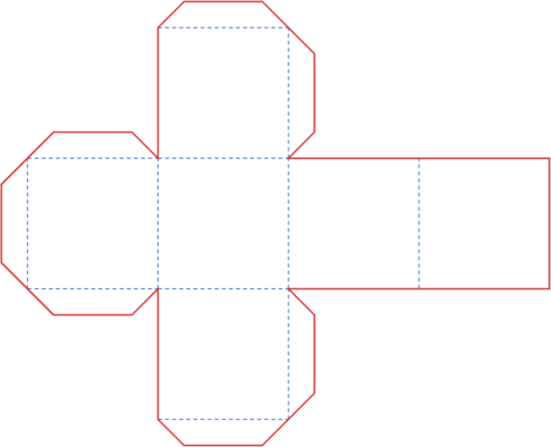
Figure 6. A box with cut lines, fold lines, and glue tabs.
The Pen tool (the pen-nib icon) draws a free-form outline point by point — useful for a custom shape such as a mountain profile:
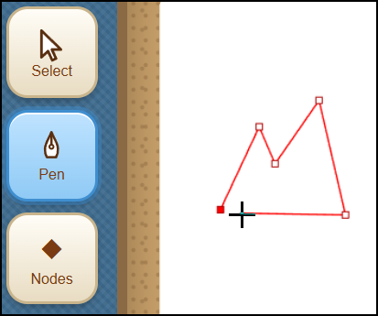
Figure 7. The Pen tool (used to draw a mountain profile in this example).
- Select the Pen icon in the Tools menu.
- Click on the mat to place each corner point. A red line follows the cursor to preview the next segment.
- To close the shape, click the first point again or press Enter.
If a point lands in the wrong place, Ctrl-Z takes it back — one point at a time — and Ctrl-Y puts it back. Pressing Esc, or choosing another tool, leaves the Pen and keeps the outline as it stands: an unfinished outline stays on the mat as an open line rather than being discarded, so nothing is lost by stepping away in the middle of one. Ctrl-Z removes the outline if it is not wanted after all.
The Pen can also carry on from an outline that is already on the mat. Wherever an outline has a loose end — after Break at Node, for example — the end fills in as the Pen approaches it. Click the end and the Pen continues from there; click the outline's other end to close the shape, or press Enter to leave it open. This is how a traced silhouette is opened, extended, and closed again to make a region that can be given a paper color, such as the foliage of a tree.

6. Editing shapes
Selecting a shape with the Select tool (the arrow) opens the Selected object panel on the right, which is where a shape is measured and changed. A shape that has been given a paper color can be selected by clicking anywhere inside it; a shape that is only an outline is selected by clicking on its outline. Moving an outline-only shape no longer means hunting for that thin line, though: press anywhere inside the shape and begin to drag, and its whole interior acts as a grip that picks the shape up and moves it in one motion.
- Move or resize — drag the middle of a shape to move it, or a square handle to resize it. An imported design, or several shapes selected together, shows a dashed box: its corners resize without changing the proportions, its sides stretch one way only. A line, or a 3D bar, has no interior middle to press; grab it near its stroke instead — the same short reach a click uses — and drag it to move it, just as with a shape.
- Nudge — with a shape selected, the arrow keys move it 0.1 mm at a time; hold Shift for 1 mm steps — a precise final adjustment after a shape has been dragged close with the mouse.
- Rotate — drag the round handle that appears above a selected shape; hold Shift to snap to fifteen-degree steps. Rotating a rectangle converts it into an editable outline. The same handle appears above a Tab, a Group, or several shapes selected together, and turns all of them as one around their shared center.
- Set the line type — click Cut, Fold, or Print Only to set the line type that determines what the die cutter does with that shape (Section 3 above). The highlighted button is the current setting.
- Paper color — give a shape the color of the card it will be cut from, so the mat shows the finished collage instead of a tangle of outlines. Choose one of the colors in the Selected object panel, or the color wheel at the end of the row for any other. The color is never cut, so the die cutter still follows the outline. It does now print, though: with registration Marks on, every colored piece prints in its color on one sheet, ready to cut out together (Section 11).
- Layer — where shapes overlap, the one drawn most recently sits in front. Back, Lower, Raise and Front change that order, so the sky can be moved behind the grass. On the keyboard, Page Down and Page Up move a shape one step, and End and Home send it to the back or bring it to the front.
- Label — right-click a shape to name it on the drawing. Type in the small box that appears above the shape and press Enter; the label then moves with the shape. Right-click again to change the wording or empty the box to remove it, drag the label to place it elsewhere, and set its size with Label size (mm). A label is never cut, never printed, and never exported.
- Exact size and position — the panel shows the measurements in a small box; click a number and type to set an exact value.
- Simplify the outline — an outline is made of nodes (the points where the line changes direction). Fewer nodes cut more smoothly. Simplify nodes reduces the count while keeping the shape; the Nodes tool (the diamond icon) lets individual points be dragged, added, or deleted.
- Delete — click the Delete button, or press the Delete key on the computer keyboard.
- Undo and redo — Ctrl-Z undoes the last change; Ctrl-Y (or Ctrl-Shift-Z) redoes it.
- Duplicate — Ctrl-C copies the selected shape and Ctrl-V pastes a copy beside it, complete with its line type and settings. Paste again for more copies.
- Break at a node — with the Nodes tool, click a node and press Break at Node. A closed shape opens there; an open line splits into two pieces. Each piece can then be Cut, Fold, or deleted on its own — three sides Cut and one side Fold makes a glue tab by hand.
- Snap to Fit — when a shape is dragged near another, their corners pull together and lock exactly; a green dot marks the shared point. The magnet button beside the zoom controls turns this off, and holding Alt while dragging moves a shape freely.
To work on several shapes at once, drag a box around them . They can then be moved, deleted, or changed to Cut, Fold, or Print together. Each selected shape is marked by a faint gray panel behind it.
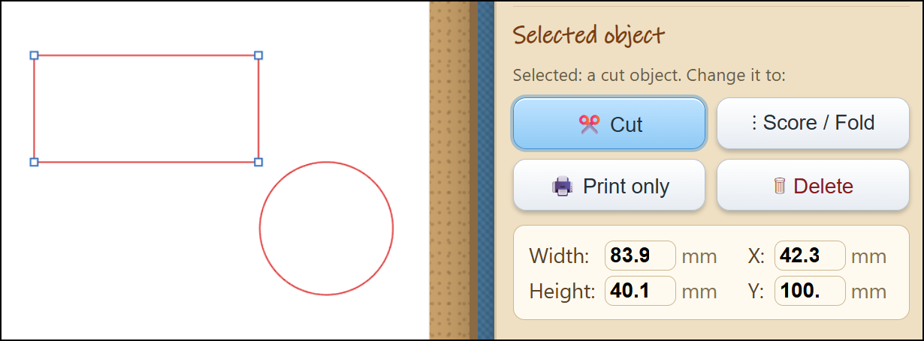
Figure 8. The Selected Object panel that is used to set the line type (Cut, Fold, Print)
and enter exact specifications for the size and position of the shape.

7. Drawing with Snap!
Snap! is a block programming language in which a turtle draws by moving across the screen — the turtle graphics that have been used in classrooms for many years. Sangala Studio can take what the turtle drew and cut it, crease it, or draw it on paper. A Snap! program therefore becomes a design, and an existing turtle program becomes one simply by choosing the color of its pen.
1. Open Snap! — Select the Snap! icon in the Tools palette. Snap! opens a window of its own. Launch Snap! using this button: a drawing can only be imported to Sangala Studio through a Snap! window that Sangala Studio itself has opened.
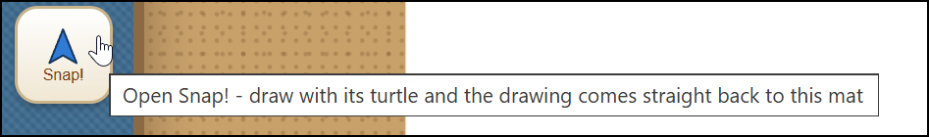
Figure 9. The Snap! button in the Tools Palette opens Snap! in a separate window.
2. Enable JavaScript — In Snap!'s settings menu (gear icon), check the JavaScript extensions box.

3. Build the script — Place the Record Turtle Paths block at the top of the drawing script, above pen down, and then place Send Paths to Sangala Studio the at the bottom of the script.
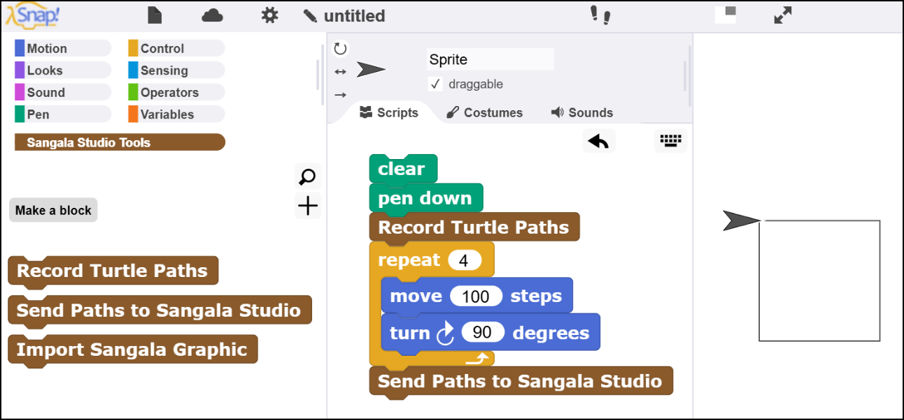z
Figure 10. The two Sangala blocks in Snap! (left), a script that draws a square
(center), and the square the turtle has drawn on the Snap! stage (right).
4. Send the Drawing — When you run the script in Snap!, it will send the drawing created by the Snap! turtle (the triangle that draws the lines) to Sangala Studio.
5. Choose what the Die Cutter will do — The drawing appears in the middle of the workspace in Sangala Studio, where it can be moved, reshaped with the Nodes tool, or combined with other shapes like any other design.
A project someone has already published can be opened instead of writing a script. Choose Open a Project from the Snap! button, paste the project's web address, and press Open. The project opens in its own window and the Sangala blocks arrive in it a few seconds later, so nothing has to be imported by hand. Any published Snap! or TurtleStitch project can be opened this way, and the same button works whichever of the published forms of the address is pasted.
The pen color determines the actions of the die cutter. A red line instructs the die cutter to cut out the shape. A blue line is interpreted as a fold line (consisting of a series of dashed cuts). Other lines are interpreted as drawn lines. The actions of each line can also be set or changed in the Sangala Studio Selected Objects panel.
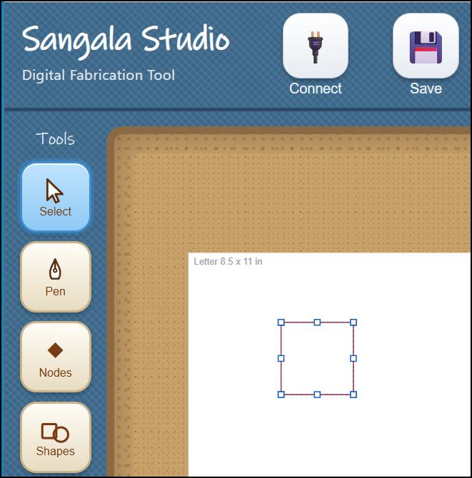
Figure 11. The design created in Snap! will appear in the Sangala Studio workspace.
To draw rather than cut, put a pen in the tool holder, choose Pen (draw) as the material in Setup, and press Make It! The die cutter draws the turtle's path at full size on paper. To cut the design out instead, put the blade back in and choose the material being cut. A drawing that mixes red and blue lines becomes a paper-craft net, in which the red lines are cut and the blue lines are creased ready to be folded.
One hundred turtle steps arrive as 20 mm, a little over three quarters of an inch, so a drawing that fills Snap!'s stage is roughly the width of a sheet of paper. A turtle step means the same 0.2 mm in TurtleStitch, so the same program cuts the same size in either. A design too large for the page can be reduced with Scale in the Setup panel.
Sangala Studio can also send a design the other way — onto the Snap! stage, where a Snap! program can use it as the costume for a sprite. This is a way to make artwork for a program, such as the dials and buttons of a dashboard, by drawing it rather than writing code for it.
1. Choose the design — draw or select the shapes in Sangala Studio. If nothing is selected, the whole mat is sent.
2. Bring it across — in Snap!, click the Import Sangala Graphic block. The design appears on the Snap! stage as a black outline. (Snap! must have been opened from the Snap! icon in Sangala Studio – as described above – so that the two applications will be able to communicate with one another.)
3. Make the Imported Graphic a Costume — Hold the Shift key and right-click the stage, then choose pen trails from the menu. A new costume will appears in the sprite's costume library.
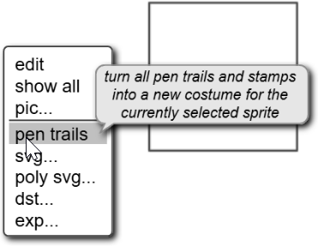
Figure 12. An imported design can be used to
create a costume for the current Snap! sprite
4. Add color — open the costume in Snap!'s paint editor and fill the enclosed areas with color.
The design crosses in black and white; color is added in Snap!. The outline itself stays in Sangala Studio, so the same design can also be cut or folded.
Troubleshooting Tip — If the blocks are missing. Sangala Studio sends them when it opens the editor, so this should not arise. If the palette is not there, choose Add Sangala Library from the Snap! button, which sends them again. Only if that fails, choose File, then Import in the editor, and select the file “Sangala for Snap.xml” from the folder Sangala Studio runs from.

8. Combining shapes
The Combine tool (the overlapping-squares icon) joins two shapes. Select one shape, then hold down the Shift key and select a second shape (which will then be highlighted in orange). Then choose:
- Union — join both shapes into one outline.
- Difference — remove the second (orange) shape from the first.
- Intersect — keep only the part where the two shapes overlap.
Difference and Intersect keep any windows a shape already has, so a second, third, and further window can be cut into the same shape — disjoint windows stay separate, and overlapping ones merge into one. This is what lets a single frame carry several openings. Combine also handles shapes built from touching or overlapping rectangles, and concave L- or U-shaped slots, without mangling the outline.
In 3D mode the Combine menu offers only Union and Intersect; Difference is not shown, because carving in 3D is done a different way — mark a shape as a Hole (it draws as a blue dotted outline) and then Union it, and the hole subtracts a void instead of adding material. Any number of shapes can be selected and combined at once, not just two, and Union honors each shape’s Solid/Hole setting, so solids merge while holes carve in a single step. The 3D side of Combine, which bakes the result into one printable part, is described in Section 23.
To place a photo inside a circle (or any outline) for a collage: open the photo, draw a shape over the part to keep, click the shape, then hold Shift and click the photo, and choose Intersect. Everything outside the shape is removed, leaving a print-and-cut of the cropped photo.
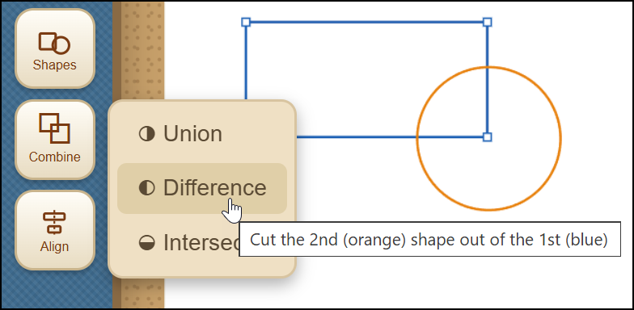
Figure 13. Using the Combine option to combine two overlapping shapes.

9. Aligning shapes
The Align tool (the centered-bars icon) lines shapes up. Select two or more shapes — draw a box around them, or click one and Shift-click another — then choose:
- Vertical — the shapes line up vertically.
- Horizontal — the shapes line up horizontally.
- Center — the shapes are centered on one another.
The largest shape stays in place and the others move to it, so Center drops a small circle exactly into the middle of a square frame.
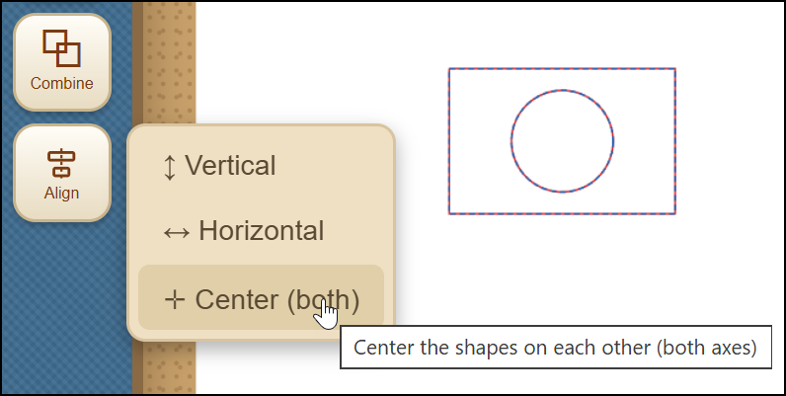
Figure 14. Using the Align option to center two shapes.

10. Mirroring shapes
The Mirror tool (the two arrows facing a dashed line) flips a selection over, so a part made for one side of a design becomes the matching part for the other. Select one or more shapes — draw a box around them, or click one and Shift-click another — then choose:
- Flip Horizontal — the selection is reversed left to right.
- Flip Vertical — the selection is reversed top to bottom.
The flip happens about the middle of whatever is selected, so the shapes stay where they are on the mat instead of jumping to one side.
Mirroring a single rectangle or circle looks as though it does nothing, because a symmetrical shape flipped about its own middle is unchanged; Sangala Studio says so when this happens. Mirror earns its place on shapes that are not symmetrical, and on assemblies of several parts. To build a symmetrical animal, make one side, press Ctrl-C and then Ctrl-V to make a copy, mirror the copy, and drag it into position.
In 3D mode Mirror flips an asymmetric solid — a sloped or roofed block, a cone, or an assembly of several blocks or bricks — into its mirror-image twin, in the same way it flips a flat shape. A part shaped for one side of a model becomes the matching part for the other.

11. Examining Fine Detail
To inspect fine detail:
- Zoom with the mouse wheel, which magnifies about the pointer, or with the plus and minus buttons at the bottom of the Fabricate Panel, which magnify about the middle.
- Fit frames the whole design, including any pieces that sit outside the page.
- Pan (when zoomed in) by holding the Space bar and dragging.
Zooming changes only the view, not the real size of the design.

12. Cutting Out a Design
- Open Setup (the gear icon) and choose the Material (Paper, Sticker Paper, Cardstock, Heavy Cardstock, Vinyl, Custom, or Pen (draw)). This is used to adjust Force, Speed, Blade, and the number of Passes; thicker material needs more force and more passes. Set the Position if the design should sit at a particular spot on the mat, then close Setup.
- Place the cardstock or other material on the carrier sheet and load it into the die cutter.
- Decide whether to print first:
  - For a plain silhouette cut from colored cardstock, leave registration Marks off and press Make It! The blade cuts the outline directly.
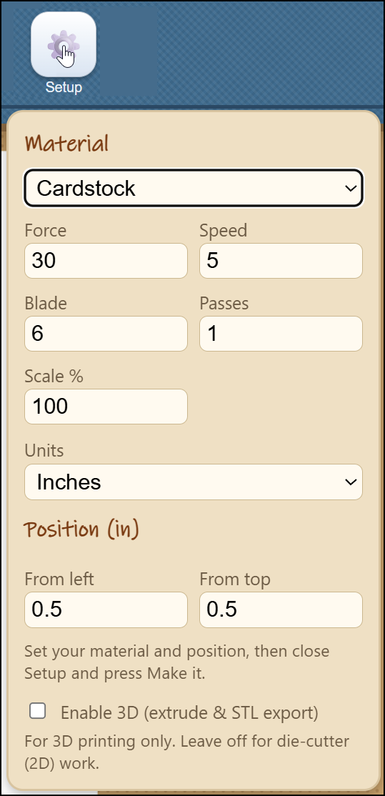
Figure 15. The Setup menu can be
used to adjust the material settings.
  - For a print-and-cut (a full-color picture, or a collage of colored pieces, printed and then cut out):
- Turn registration Marks on,
- Select Print to print the artwork with three registration marks (small targets the die cutter reads to line itself up),
- Load the carrier sheet into the die cutter,
- Then select Make It!
A sensor in the tool head of the die cutter will use the registration marks printed on the page to locate the position of the artwork and cut exactly around the areas designated by cut lines.
A collage made from colored pieces is cut this way in a single pass. Give each piece a paper color, arrange them on the page, and Print: every piece prints in its color on one sheet of white cardstock. Make It! then cuts every outline at once, so the pieces need not be cut one color at a time. Because the color is printed rather than cut from colored card, the cut edge shows the white core of the sheet.

13. Saving the Design
The Save button (the disk icon, between Connect and Open) opens a small menu with two ways to keep a design. They serve different purposes, so it is worth knowing which to reach for.
- Save project writes a .model file that reopens the design exactly as it is now. It remembers everything — whether the work is in 2D or 3D mode, the workspace it was drawn on, the Force, Speed, Blade, and other settings, how shapes are grouped, and any solid parts that have been baked together in 3D. It also keeps a reference photo and an in-progress trace, so a half-finished tracing job reopens right where it was left. This is the file to save while a design is still being worked on.
- Save as SVG writes an interchange file — the common drawing format that other programs read, such as TinkerCAD or the die cutter's own tools. Its geometry is re-sampled when the file is reopened, which makes it a fine file to hand to another program but a lossy one to reload and keep editing. When the design needs to travel outside Sangala Studio, this is the file to send.
A reference photo is treated differently by the two choices:
- Save as SVG does not store a photo opened only as a reference for tracing; the SVG carries the finished outlines alone.
- Save project keeps the reference photo together with the in-progress trace, so the picture and the tracing sliders reopen as they were.
- Once the background of a shape has been removed to create a silhouette outline (or it has been cropped to a shape), the picture is no longer just a reference — it becomes part of the print-and-cut design. Either save keeps it, and it reappears when the file is reopened.
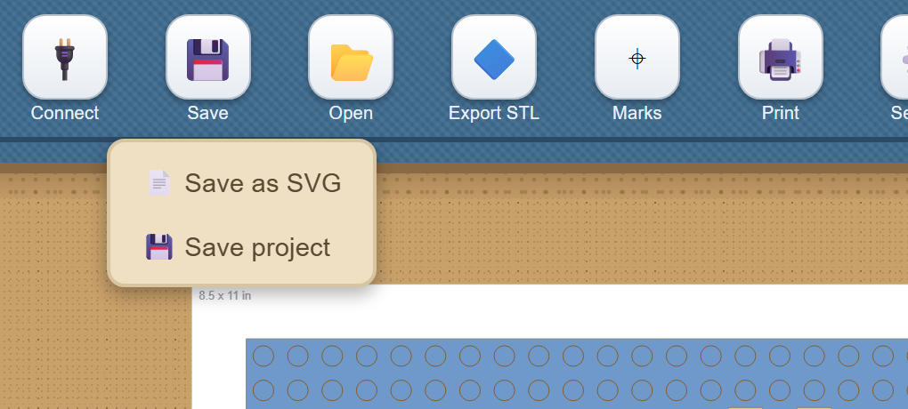
Figure 16. The Save menu, with its two ways to keep a design: a project that reopens exactly, and an interchange SVG.

Part 2. Three-dimensional Design Tools

14. Designing in 3D
Sangala Studio has a full three-dimensional mode for objects made on a 3D printer, which builds a solid object up in thin layers of plastic rather than tracing a flat outline with the die cutter. Everything in the earlier sections — drawing shapes, tracing a photo, combining and aligning — still applies; 3D mode adds height, so a drawn outline becomes a solid you can hold. A design made in 3D is exported as an STL file, the file a 3D printer reads, to be printed. It can also be saved as a project so that it reopens exactly as it was left, in 3D mode and with its settings (Section 13). The STL is the file that prints the object; the project is the file that keeps the design.

15. Switching to 3D
The button at the top right, next to the logo, switches between 2D and 3D. It reads 2D for die-cutter work; pressing it changes the label to 3D.
Because a 3D design is printed rather than cut, entering 3D hides the die-cutter controls that no longer apply: the Fabricate heading and the green Make It! button, the Material heading and its selector, the progress bar beneath them, and Simplify Nodes (an edit meant for a flat cut outline). The die-cutter connection message is not shown either. In their place, three controls appear that stay hidden in 2D: the Part tool in the Tools Palette, and the 3D View and Export STL buttons near the top. Switching back to 2D restores the die-cutter controls.
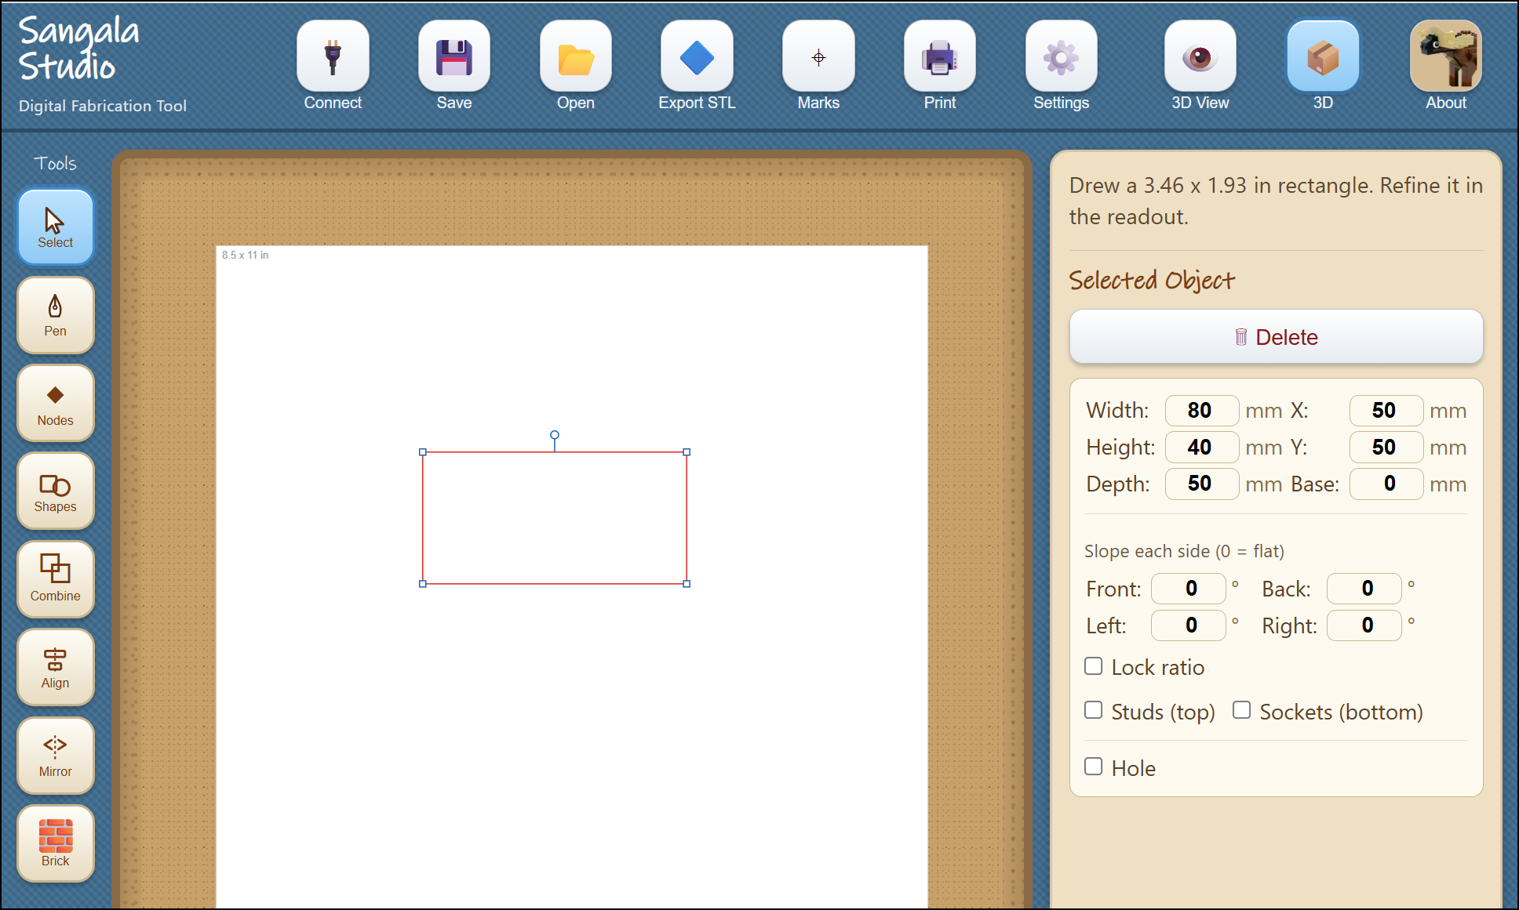
Figure 17. Switching to 3D mode reveals the Part tool, the 3D View,
and Export STL, and adds depth controls for 3D objects.

16. Giving a shape depth
A flat shape becomes a solid when it is given a height. Any drawn shape can be raised — a rectangle, a circle, or a free-form outline drawn with the Pen — so that a circle becomes a cylinder and a rectangle becomes a box. The sides rise straight and the top stays level; a sloping top is set separately, below. Select a shape and the Selected object panel shows two further measurements:
- Depth — how tall the object stands, the distance the flat shape is raised to form a solid.
- Base — how far the object sits above the printer bed. A Base of zero rests the object on the bed; a larger Base lifts it, which is useful when one part is meant to rest on top of another.
Both are counted in plates. A plate is the thinnest standard LEGO piece, and three plates stack to the height of one brick, so a Depth of 3 is one brick tall and a Depth of 6 is two. Every height in 3D mode is given this way, because a figure assembled from bricks is easier to think about in plates than in millimeters. The geometry itself is still held in millimeters — a plate is 3.2 mm and a brick 9.6 mm — and only the fields on screen convert.
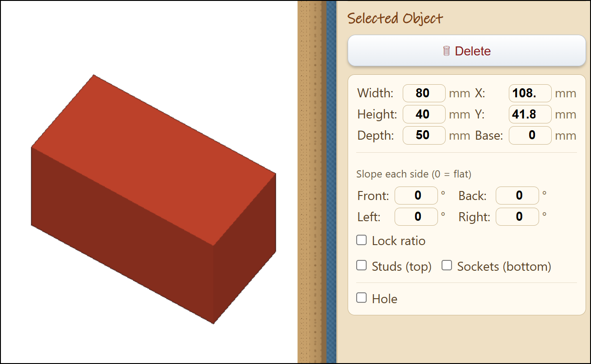
Figure 18. A rectangle selected in 3D, with the Selected Object panel showing its Depth and Base.

17. Sloping a top
A level top can be made to slope, so an ordinary block becomes the back of an animal or the pitch of a roof. Slope is set one side at a time, by angle. With a shape selected in 3D, the panel shows a Slope each side group: a rectangle gets four fields named Front, Right, Back, and Left; any other convex shape gets numbered fields, Side 1 through Side N. Each angle is measured from vertical, so 0 leaves that side a straight, upright wall, and a larger angle ramps that side of the top inward. Focusing a Slope field highlights the matching edge in green on the plan, so it is clear which side each number controls.
Because each side is independent, the same control builds several roof shapes:
- Slope one opposite pair of sides and the top narrows to a ridge, like the gable of a house.
- Slope every side and the top can collapse to a single point — an apex, giving a pyramid or a hip roof.
- Keep the angles small and the top stays broad and flat, with only its edges beveled.
A circle has no sides to name, so instead of the per-side fields it shows one Cone taper field. Zero leaves a straight cylinder; a moderate taper draws the rim in to a truncated cone, and a steep one brings it to a point for a full cone.
Once any side is sloped — or a circle is given a cone taper — an Invert checkbox appears. Invert mirrors the slope in Z: the top stays full and flat while the underside falls away instead. This is the shape that fills the underside of an overhang, the counterpart another part rests against.
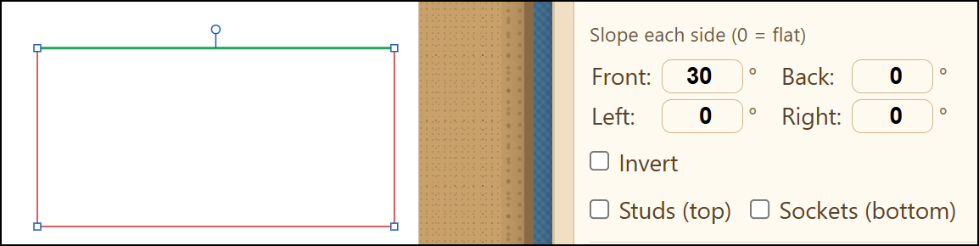
Figure 19. The per-side Slope fields (Front, Right, Back, Left)
with one edge highlighted in green on the plan, and the Invert checkbox.

18. The Part tool
The Part tool (the brick icon in the Tools Palette, shown only in 3D) places a ready-made LEGO part. Pressing it opens a short menu of the parts it can place: Brick, Plate, Slope, Inverted Slope, Round Brick, Cone, and Wedge Plate. Choosing one arms the tool, and the next click on the mat places that part; pressing the tool again while it is armed puts it away.

Figure 20. The Part menu, with the seven LEGO parts the Part tool places.
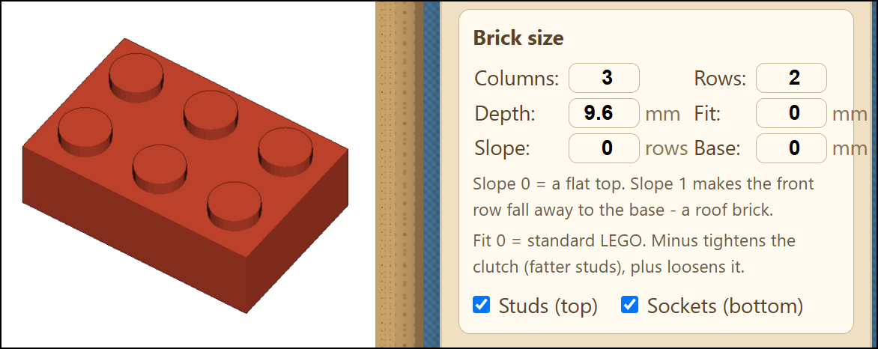
Figure 21. The Part tool and its Brick size panel: Columns, Rows, Depth, Fit,
Slope, and Base, with the Studs, Sockets, and Inverted checkboxes.
Once a part has been placed and selected, the Brick size panel adjusts it:
- Columns and Rows set how many studs the brick has across and deep. A brick of one column and one row, given a large Depth, becomes a tall, narrow post — for example, a leg.
- Depth sets the brick's height, in plates: 3 is one brick tall.
- Fit adjusts how tightly two printed bricks snap together. Zero is the standard LEGO size. A minus value tightens the grip by making the studs slightly fatter; a plus value loosens it. Printers differ, so if new bricks feel loose, try -0.2 first and adjust in small steps.
- Studs (top), turned off, leaves the top smooth — suited to a surface such as a wing that should carry no studs.
- Sockets (bottom), turned off, closes the underside with a flat base — suited to a part that is glued to a surface rather than pressed onto studs.
- Slope ramps the top of the brick down over the number of stud rows given, leaving a roof-shaped brick. Zero is a flat top.
- Inverted, offered once a Slope is set, turns the wedge upside down: the top stays flat and keeps its studs while the underside falls away.
- Base lifts the brick above the printer bed, so one brick can sit on top of another. Zero rests it on the bed.
The brick's own Slope and Inverted controls are separate from the per-side Slope described above, and work as they always have.
A part dragged on the mat lands on the stud grid. Snap to Studs — the grid button beside Snap to Fit below the workspace, shown only in 3D — pulls a dragged part onto the 8 mm lattice every LEGO stud sits on, so parts line up with one another, and with an imported mosaic, without being nudged afterwards. Holding Alt while dragging moves a part freely, and the button turns the behavior off altogether.

19. Previewing in 3D
The 3D View button shows the object as a rotatable model. Dragging rotates the model and the scroll wheel zooms, so it can be turned to inspect its underside. A Show the build plate checkbox, which appears while the 3D View is open and begins unchecked, adds the Bambu A1 Mini bed beneath the object; the object then appears at true size against the printer, and the Base value reads as the gap between the object and the bed. Pressing 3D View again returns to editing.
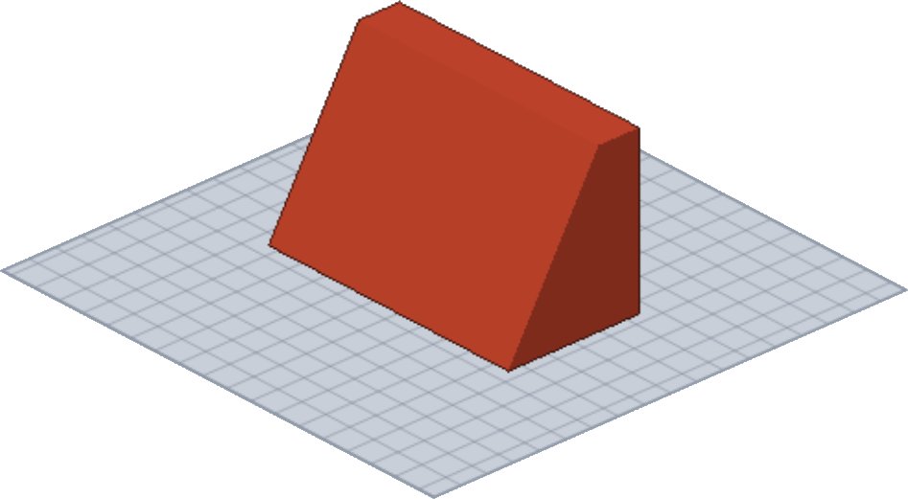
Figure 22. The 3D View, showing a rotatable model resting on the build plate.
The plate is drawn beneath the model, so a design large enough to cover it hides it completely. Its edge is therefore drawn over the model as well, as a dashed rectangle, and the label beneath the view gives the bed’s size: 180 by 180 mm on the A1 Mini. When the design is larger than the bed, the label also gives the design’s own size and says that it runs off it. A relief laid out on a Letter page is 216 mm wide and does not fit an A1 Mini; such a design is printed a piece at a time (Section 32).
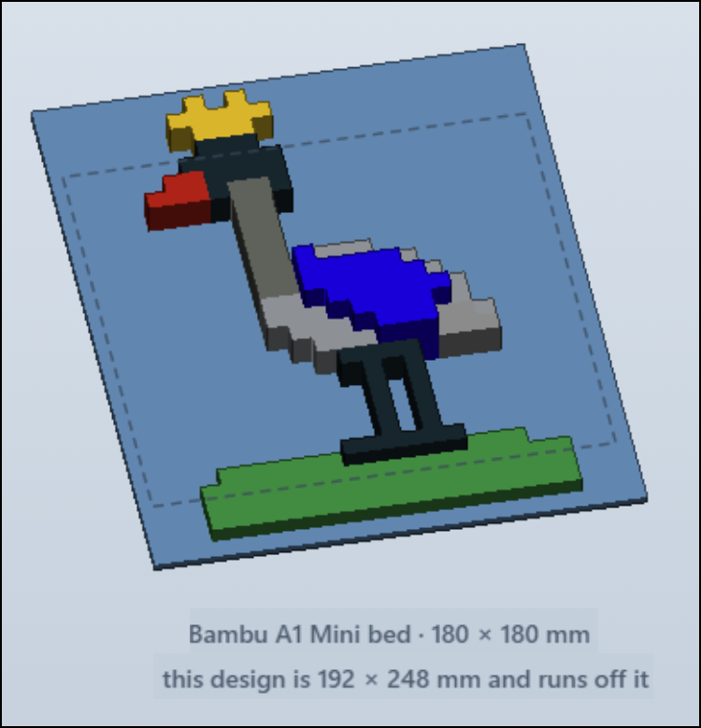
Figure 23. The build plate outline over a design that runs off the printer bed.

Nothing is exported below the plate. A 3D printer has no room beneath its bed, so when any part of a design would sit below zero — as the mirrored half of a figure does, since it reaches behind the backdrop — the whole build is raised until its lowest point rests on the plate. Every piece moves by the same amount, so the parts keep their positions relative to one another.

20. Marking a Shape as a Hole or a Guide
In 3D, a shape need not only add material — it can also take material away. Every 3D shape, bar, or baked part has a Hole toggle in its details. Left unchecked, the shape is an ordinary solid. Checked, it becomes a hole: it is drawn as a blue dotted outline, and instead of adding material it carves a void out of any solid it is grouped or combined with. A hole on its own makes nothing — it needs a solid to cut into. Marking a shape as a hole is how a window, a socket, or a bored channel is made, and it is the key to combining in 3D, described below.
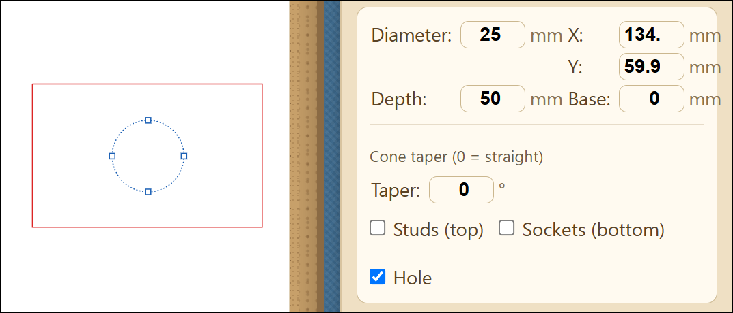
Figure 24. A shape with the Hole toggle checked, drawn as a blue dotted outline over a solid.
When the combined shape is rendered in the 3D Viewer, this is the result.
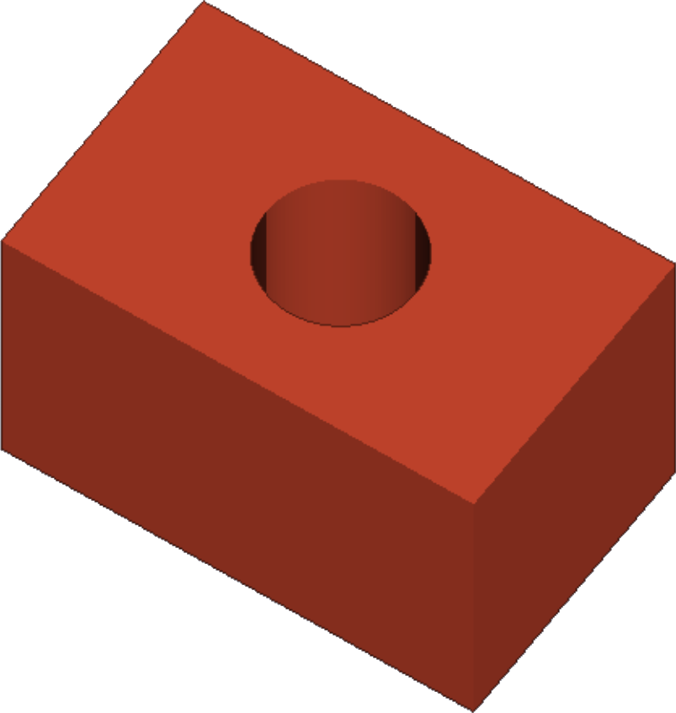
Figure 25. The effect of combining a hole with a solid rendered in the 3D Viewer.
A shape can also be marked a Guide. Where a Hole says take material away, a Guide says this was never material: it is scaffolding to build against. A guide is drawn on the plan as a pale dashed outline, and shows pale in the 3D view behind whatever is placed inside it, but it is never exported to STL and is never sent to the die cutter. Holding the massed shape of an animal in view as a guide, and building the real parts inside it, is the usual way a figure is begun. Solid, Hole, and Guide are the three roles a shape can take in the 3D build, and each is set by a checkbox in the shape’s details.
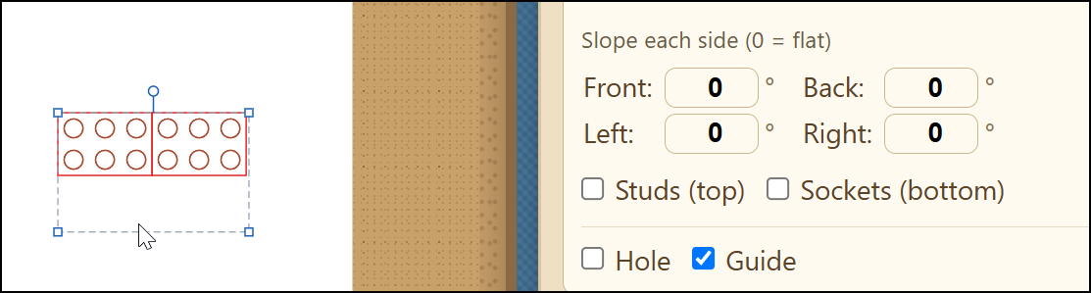
Figure 26. A shape marked Guide, with the real parts built inside it.

21. 3D bars
A straight line, which cuts or creases in 2D, can become a solid rod in 3D. Draw a Line (from the Shapes menu), select it in 3D, and turn on its 3D bar toggle. The bar runs along the line at the Base height, and the line's position and angle place and aim it — so a line laid across a part and lifted to the right Base passes a rod straight through it. Choose the cross-section in the panel: round, set by Diameter, or rectangle, set by Height and Width. A bar is a 3D object with no meaning to the flat die cutter, so it is never cut; on the plan it is drawn in teal, distinct from a red cut line or a blue dashed fold.
A bar earns its place when combined with a part. Mark it a Hole and it bores a channel — an axle hole through a wall. Leave it solid and it adds a peg. Either way, select the bar together with the part and Combine, below.
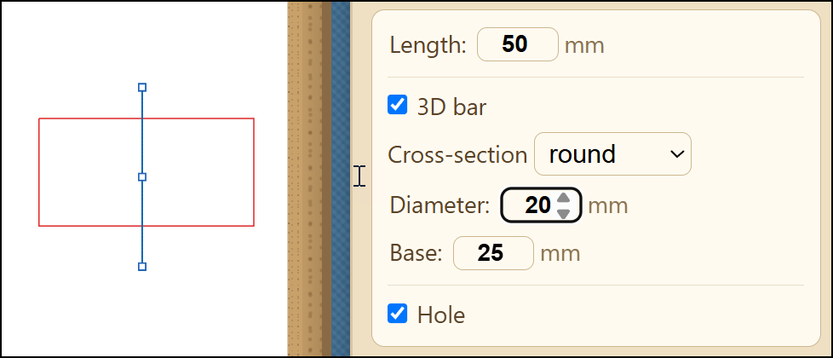S 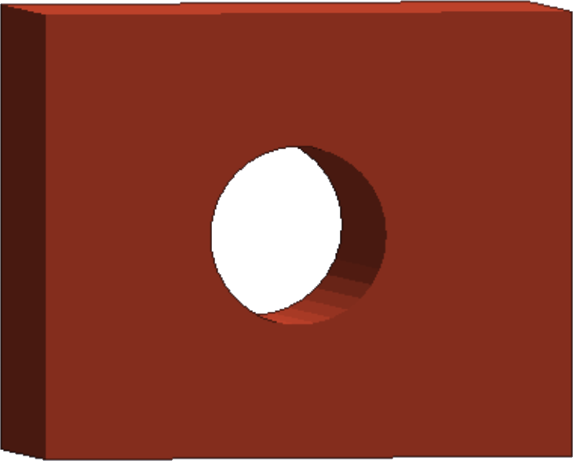
Figure 27. A line turned into a 3D bar, shown teal on the plan (left)
and as a round rod through a block in the 3D View (right).

22. Grouping pieces
Group and Ungroup (the buttons in the details panel) bundle pieces so they move and select as one. Grouping does not weld the pieces together and does not change their geometry: each grouped solid keeps its own shape and its own color in the 3D View, and Ungroup takes them apart again. Grouping is a way to handle several pieces as a unit while you arrange them, not a way to merge them.
To group, select two or more pieces — draw a box around them, or click one and Shift+click another — then press Group. Groups nest: to add a piece to an existing group, select the group, Shift+click the new piece, and Group again. Ungroup peels off one level at a time, so a group built up in steps comes apart in the same steps.
Grouped solids that touch still print as one object, because the printer's slicing software joins overlapping plastic on its own. To merge pieces into a single welded part inside Sangala Studio — one shape with one surface — use Combine instead.
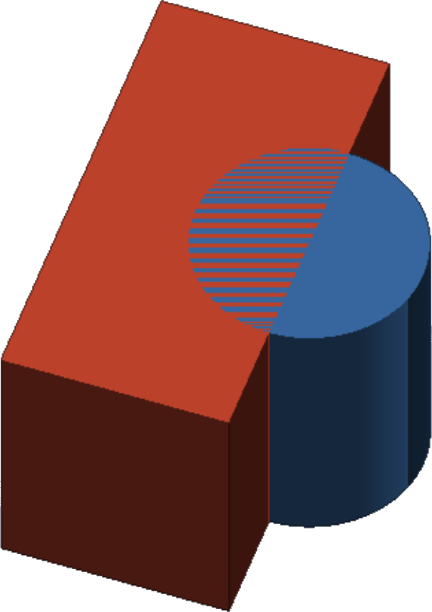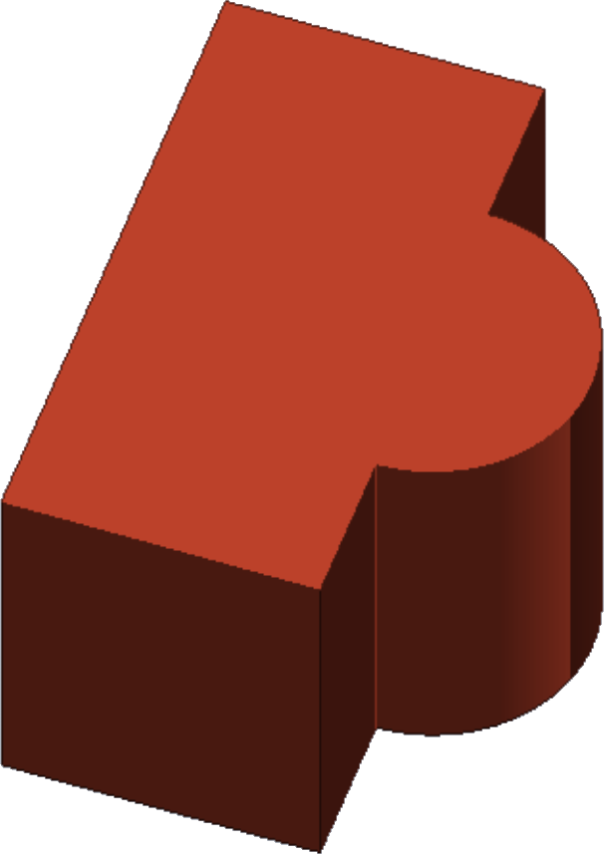
Figure 28. Two shapes selected and grouped. The shapes on the left have not been combined and
are shown in separate colors. The shapes on the right have been combined and are one color.

23. Combining in 3D
Combine (the overlapping-squares icon, described for flat shapes in Section 8) does far more in 3D: it runs a true three-dimensional boolean and bakes the result into a single solid part. Select two or more 3D solids — shapes with Depth, 3D bars, or parts already baked from an earlier Combine — and the Combine menu offers two operations:
- Union — merge the pieces into one solid. Union also honors the Hole flag: any solid in the selection is added, and any Hole is carved away, so a single Union both merges the solids and cuts the holes.
- Intersect — keep only the region where all the selected pieces overlap.
The 3D menu does not show Difference, because carving is done with a Hole: mark the cutting shape a Hole and Union it. Any number of pieces can be combined at once, not just two. If a selected shape is still flat, Combine asks for a Depth first, since a flat shape is not yet a solid.
The result is one baked part. It saves and reopens exactly, steps back and forward through Undo and Redo, and can be moved, rotated, and resized like any shape; its details panel gives it its own Depth and Base. With the 3D View off, a part that was carved shows its openings as dashed lines on the plan, so a hole stays visible even in the flat view. This baking is what sets Combine apart from Group: Group bundles pieces that stay separate, while Combine welds them into one committed part.
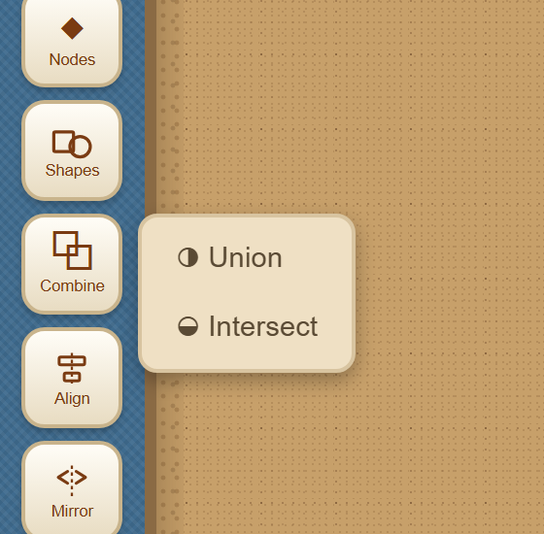
Figure 29. The Combine menu in 3D offers Union and Intersect; carving is done by marking a shape as a Hole.

24. Seeing a hole before you combine
Combine bakes a result that is not easily adjusted afterward, so it helps to check the fit first. Grouping a solid with a Hole gives a live preview: the moment the two are grouped, the 3D View shows the void carved out, without baking anything. You can nudge the Hole, rotate the model, and confirm the cut lands where you want it. The pieces stay separate and Ungroup-able the whole time, and the same carved shape is what the STL exports — so a grouped solid and Hole prints as a solid with a hole even before you Combine. When the fit is right, Combine bakes it into the single committed part.

25. Building a curved, tapering part
A tail, a horn, a leg, or a trunk is built as a stack of circles, each one a little lower and a little smaller than the one above. A circle becomes a cylinder, and Base sets how high off the printer bed it sits, so the stack hangs one piece beneath the next. Group the stack to move it as one while you shape it — the touching cylinders still print as a single solid because the slicer joins them — or Combine with Union to bake it into one welded part. Three things decide whether it reads as the shape it is meant to be:
- Curve by turning, not by sliding. Moving each circle sideways by the same amount gives a straight diagonal, however large the steps, and the part leans rather than curves. What the eye reads as a curve is a change of direction, so turn the part instead: start it at an angle where it meets the body and bring it steadily upright by the tip. A tail that leaves the rump about 65 degrees off vertical and finishes hanging straight down turns through some 60 degrees, which cannot be mistaken for a lean.
- Taper without reversing. Make every circle smaller than the one above it, all the way down. A part that narrows and then widens again reads as no taper at all, and about two and a half to one, root to tip, is enough to see. A tuft at the end of a tail may flare back out, as it does on the real animal, as long as it stays clearly narrower than the root.
- Swing it across the view. The 3D View looks down on the model at an angle, so a part curving toward the viewer has its bend pointing almost at the camera, where it flattens to nearly nothing — the curve is real and still looks straight. Curving it across the view spends the movement where it can be seen.
Position has the same trap: a part tucked inside the footprint of the body it hangs from is hidden underneath it. A part that is built correctly and cannot be seen looks exactly like a broken one, so build it, then rotate the model and check. For printing, keep the thinnest section at about 3.5 mm or more, since anything finer snaps in handling, and a part that hangs in free air needs support material turned on. If that proves troublesome, the sturdier answer is to draw it into the body outline with the Pen, so that it becomes one closed shape with the body, prints flat, and cannot break off.
The sample file Buffalo Tail (fused and unfused).svg is a worked example: the same tail built twice. On one side the stack is left as separate, grouped cylinders, and each shows in its own color in the 3D View; on the other the stack has been Combined into one part, which reads as a single color. That change of color is the quick sign of whether a stack has been baked into one piece with Combine or is still a bundle of separate ones.

26. Saving for the 3D Printer
Export STL (the diamond icon, shown only in 3D mode) writes an STL file, which is then opened in the printer's own software (Bambu Studio) to print the object. With nothing selected, it exports the whole model — every piece together — as one file. To save a single piece on its own, select it first and then Export STL; you can select several pieces to export just those. Export STL is a separate button, not one of the choices in the Save menu (Section 13): the Save menu keeps your design, while Export STL produces the file the printer reads.

Part 3. From a Mosaic to a Printed Figure

27. Opening a mosaic
Sangala Mosaic is the companion program in which a photograph is reduced to a mosaic of colored LEGO tiles. A mosaic saved there opens directly in Sangala Studio, where it becomes the starting point for a three-dimensional figure: what was a flat picture made of tiles becomes a set of solids that can be given height, stepped forward and back, and printed.
Open a .mosaic file with the Open button, as any other design is opened. What arrives depends on the work done in Mosaic:
- Each named mass becomes a Part. A mass is a region of tiles grouped and named in Sangala Mosaic — the head, a wing, the frame around the picture. Each arrives in Studio as a part carrying that name, and the name identifies it everywhere in the application afterwards.
- A name produces one part for each separate region it covers. Tiles of one name that fall in two places which do not touch arrive as two parts, since a corner touch cannot carry material. A crane’s body may therefore arrive as three parts, all named Body; they are gathered back together in the Parts panel (Section 28).
- Tiles in no mass arrive as background pieces, so nothing in the mosaic quietly disappears.
- Each part keeps the color of its tiles: on the flat plan every tile shows its own color, so eyes, a beak or a muzzle read where they were drawn, while in the 3D view and in the exported model the part takes the commonest of them, because it extrudes as a single solid.
- Studs are shown to begin with, because studs on the 8 mm grid are what make a figure read as built from LEGO.
An imported part is a three-dimensional object only. Its outline is a staircase of tile edges rather than a drawn path, so it is never sent to the die cutter.
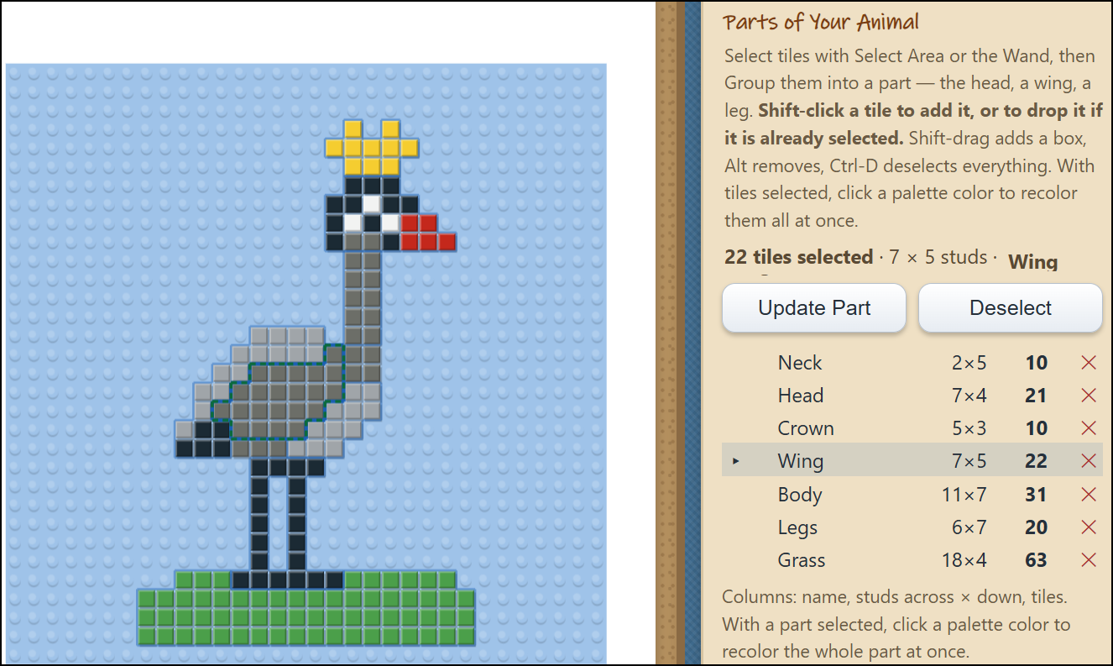
Figure 30. A mosaic opened in Sangala Studio: each named mass has become a part.
A design meant for brick wants a workspace to match. A mosaic tile and a LEGO stud are both 8 mm, so the size of a design follows from the number of studs it spans: a full baseplate of 32 by 32 studs is 256 mm square. That is wider than the 216 mm Letter page, and a full-plate design laid out on the page hangs off it. Settings, Page size offers LEGO baseplate 32 x 32 studs for this, and it is the workspace to choose whenever a design is intended for brick or for extrusion. The Letter page beside it is the die cutter’s material and has no bearing on work in brick. A design kept with Save project remembers which workspace it was drawn on and reopens on that one.

28. The Parts panel
A figure imported from a mosaic has many parts, and setting each one by selecting it in turn is slow. The Parts panel lists them all at once. It appears above the Selected object panel whenever a design in 3D holds two or more parts, and it is independent of the selection: every part is listed whether or not it is picked on the mat. Each row gives a part its Show box, its color, its name, the plane it belongs to (Section 29), its Depth, its Base, and its Studs.
- Parts sharing a name are one row. However many separate pieces the import produced, one name is one row, and every field in that row acts on all of them at once. Where the pieces disagree — three pieces at three different depths — the field reads as a dash rather than imposing one piece’s number on the others; typing a value sets them all.
- A part is named by double-clicking its name, the gesture Sangala Mosaic uses for the same act. An unnamed part reads unnamed, in italic, and has a row of its own. Giving a part the same name as another merges the two into one row, which is how a stray piece joins the part it belongs to; clearing the name puts it back on its own.
- Depth and Base are in plates, as every height in 3D mode is. Depth is how thick a part is, how far it stands out from where it starts; Base is where it starts, measured up from the backdrop. The two are easily mistaken for each other, and the difference between them is what a relief is made of.
- The color square opens a palette for that part. In 3D the color shows both in the view and in the exported model.
- The Show box leaves a part out. Clearing it removes the part from the 3D view and from the exported file, which is how a build is exported in pieces (Section 32).
- Studs can be turned off for one part, and the heading of the Studs column turns them off, or on, for every part at once. That is the quickest way to see the massing of a figure without the pattern of studs across it.
- Clicking a row selects that part on the mat, and selecting a shape on the mat highlights its row.
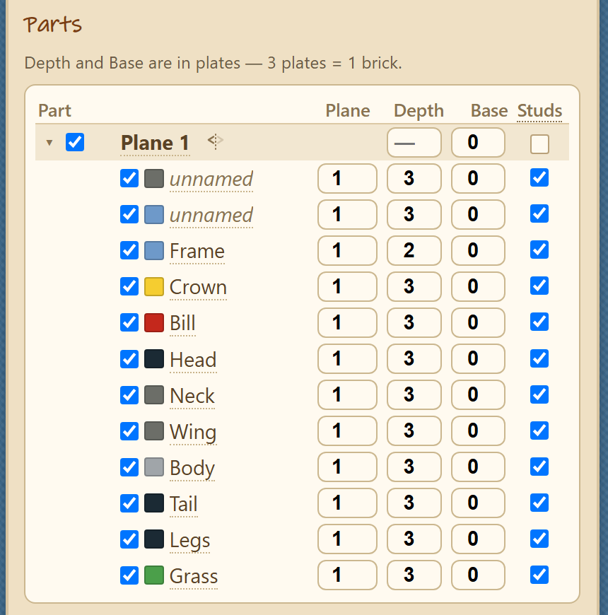
Figure 31. The Parts panel, listing every part with its plane, depth, base, color, and studs.

29. Planes
Setting a relief one part at a time is still the wrong grain: the frame of a picture belongs at one depth and everything in front of it at another. A plane groups the parts that take a depth together. It is called a plane rather than a layer because layer already means something else here — which shape is in front of which — while a plane is the idea Illustrator calls a layer: a named group with a depth and a switch to hide it.
Parts sit under their plane in the list. Each plane heads its own block and its parts follow, indented beneath it. A part is moved to another plane by typing that plane’s number in its Plane column.
A plane heading carries:
- A triangle that folds the plane’s parts out of the list. Folding is a view control only: a folded plane is still in the 3D view and still in the exported file. Folds are deliberately not saved with the design, so a reopened file is fully expanded.
- A Show box for the whole plane. Clearing it takes the plane out of the 3D view and out of the exported file. When some of its parts are hidden and others are not, the box shows neither state.
- A name. Double-click it and type: Frame or Background reads better than Plane 2 once a relief has several. The plane’s number stays in front of the name, because a part is still moved between planes by number.
- Depth and Base for every part in the plane, in the same columns the parts use. Setting either on the heading sets it on every part below. Where the parts disagree, the field reads as a dash rather than a number.
- A Studs box with three states: studs shown on every part in the plane, hidden on every part, or each part left to its own setting. The third state is the point of it — the plane overrides the parts without rewriting them, so clearing the override brings every part’s own setting back exactly as it was.
- A mirror control, described in Section 31.
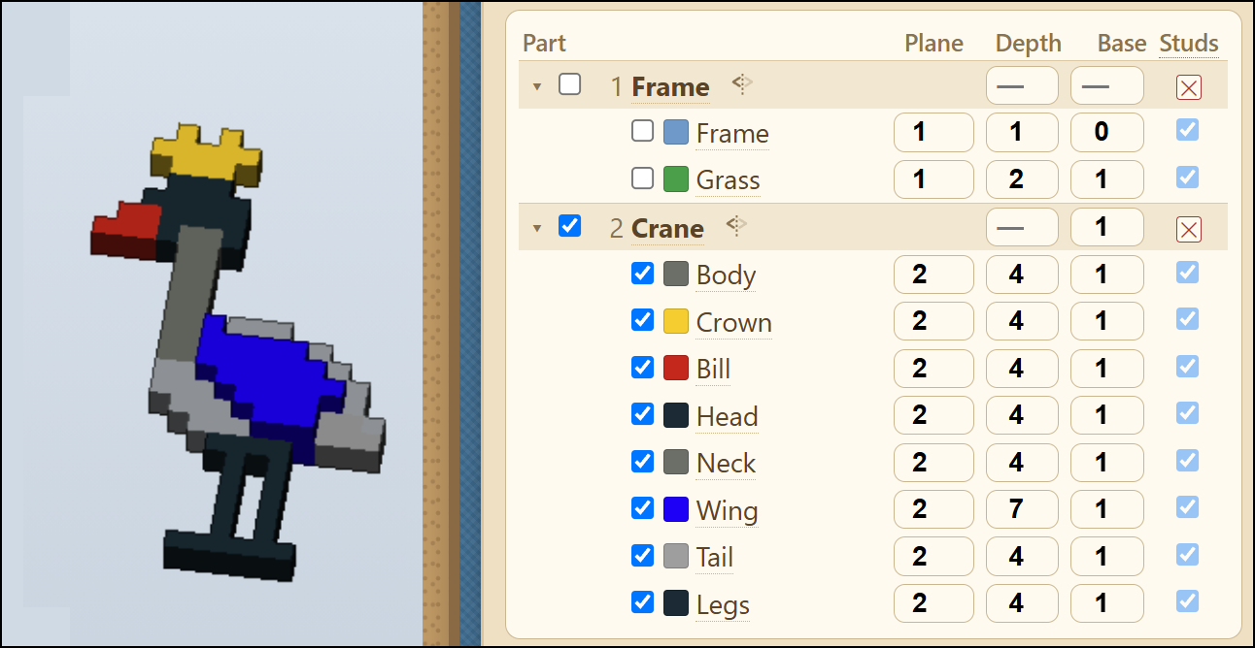
Figure 32. Parts listed under their planes, with one plane showing and one hidden.

30. Setting a relief
A bas relief is a picture that stands out from a flat background by a small amount, so that it is read as a picture rather than walked around as a sculpture. In Sangala Studio the background is the backdrop the parts stand on, and the amount a part stands out from it is its Base.
Depth and Base do different work, and a relief needs both:
- Depth makes a part solid. A part with no Depth is a flat outline with nothing to print.
- Base lifts a part clear of the plane behind it. That step is the relief itself: the head raised one plate above the neck, the neck one above the frame.
A step of one plate — 3.2 mm — is enough to read, because the eye reads the shadow at the edge of a step rather than the height of it. A relief built from steps of one and two plates therefore carries a picture as well as one built from whole bricks, and prints in a fraction of the plastic and the time.
The work is done on the plane headings rather than on the parts. Give each plane its Base in turn, working forward from the backdrop, and every part in that plane follows. A shallow relief is easier to judge with the studs turned off, which the Studs box on a plane heading does without disturbing the setting each part will return to.
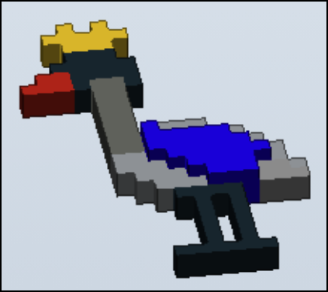
Figure 33. A relief (the wing of the crane) seen at an angle.

31. Mirroring a plane
A relief has a front and no back. Mirroring gives it one. The mirror control on a plane heading reflects that plane through the backdrop, so that whatever stands in front is matched by a reflection behind it and the figure reads from either side.
Mirroring is set on a plane rather than on the whole design, so one figure can be both things at once: the frame of a picture stays flat while the animal in front of it is mirrored into the round.
The control has three states, and pressing it moves to the next:
- Front half only — the relief as it was authored.
- Both halves — the figure in the round.
- Back half only — the reflection on its own.
The back half is a true reflection and not a second copy of the front. Two fronts glued back to back would give a figure facing the same way from both sides, which no solid object does.
Because the reflection is taken about the backdrop, Base decides whether a mirrored part comes out as one piece or two. A part at Base 0 spans the backdrop and mirrors into a single solid, which is what the body, head and tail of an animal want. A part raised above it mirrors into two pieces standing twice its Base apart, which is how one drawn part becomes a pair of legs or a pair of horns. Separation is achieved by elevating the base before extruding.
The Mirror tool on the toolbar (Section 10) is a different thing: it flips a design within its own plane, left to right or top to bottom. The mirror on a plane heading works in the third dimension, through the backdrop.
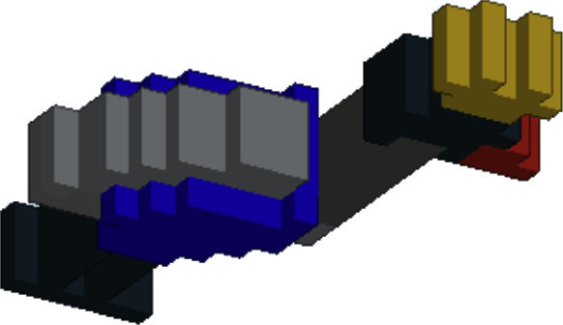
Figure 34. A mirrored plane: the figure now reads from either side.

32. Exporting a figure in pieces
The exported model is whatever the 3D view is showing. That one rule takes the place of a set of export options: hide a plane, hide a part, or show one half of a mirrored figure, and the file written by Export STL contains exactly that. Two things follow from it.
A build too large for the printer is exported a piece at a time. A relief laid out on a Letter page is 216 mm wide and does not fit the 180 mm bed of an A1 Mini. Hide everything but the legs and export; then show the legs alone and export those. Each file is printed separately and the parts are assembled afterwards.
A figure in the round is printed as two halves. A mirrored figure has overhangs on both sides, and printing it whole needs support material beneath them; each half laid flat side down needs none. Set the mirror control to the front half and export, then to the back half and export, and glue the two together.
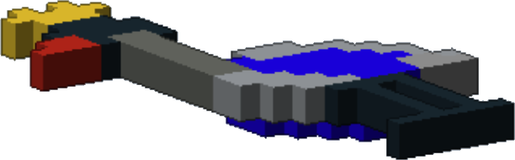
Figure 35. The bottom half of a mirrored figure.

Part 4. From a Brick Figure to a Printed Figure

33. Opening a brick figure
Sangala Blocks is the companion program in which a figure is built from real LEGO bricks. A design saved there opens directly in Sangala Studio with the Open button, in the same way any other design is opened. Every brick becomes a solid that can be given depth, stepped forward and back, and printed.
The figure arrives in profile, drawn as Sangala Blocks draws it, and the depth of the figure is carried on each piece as Depth and Base. It arrives at its true size: a brick figure is already a printable object, so nothing is scaled on the way in.
A design saved as a relief rather than as a standing figure is not read. A message says so rather than opening it incorrectly.

34. What a brick carries across
Each brick arrives as its own measured shape rather than as a plain block. A slope keeps its ramp and the short vertical lip at its foot; an inverted slope rests on one stud and spans two; a wedge keeps its curve; a round plate is a circle. The shapes are measured from the parts themselves, so a part is the size and shape it really is.
Three things do not cross. A brick's studs are not carried, nor its hollow underside and anti-stud tubes, neither of which a printed piece needs. The curved upper surface of a wedge lies across the direction a piece is extruded and is not carried either, so a wing prints as a plate of the correct shape rather than a sculpted one. A part the program does not recognize arrives as a plain block of the right size, so a design still opens whole.
Pieces imported from Sangala Blocks are for printing only. They appear in the Parts panel and in the 3D view, and they are never sent to the die cutter.

35. Named elements become planes
A group given a name in Sangala Blocks — a head, a crown, a wing — arrives as a plane, listed by that name in the panel described in Section 29. Each element can be folded away, hidden, mirrored, and given a Depth and a Base as a whole, so the parts of a head move together rather than one brick at a time.
Anything left unnamed arrives together in a plane of its own at the end of the list. Naming a group in Sangala Blocks before saving is therefore what decides which parts of a figure can be worked with as one piece.

Appendix A. Installing Sangala Studio
Sangala Studio is published in the Educational CAD Model Library (www.CADLibrary.org). It is open-source software and can be freely downloaded. It currently runs on Windows 11 computers. A version for the Macintosh is in development.
To install it:
- Open the Sangala Studio entry in the CAD Library at:
https://www.cadlibrary.org/objects/V3LXPYQH
- Select Computer Software under the Download section.
A compressed ZIP folder is saved to the Downloads folder of the local computer.
- Right-click the downloaded folder and select Extract All.
- Open the folder that is extracted and double-click “Update SangalaStudio.cmd”.
Features are added to Sangala Studio regularly. The copy in the library is the version that was current when the entry was last deposited. The updater replaces it with the most recent version.
- Double-click “SangalaStudio.exe”.
Sangala Studio will open in the web browser.
- A Sangala Studio “Bridge Notification” will appear in the notification area at the right of the taskbar while Sangala Studio is running.
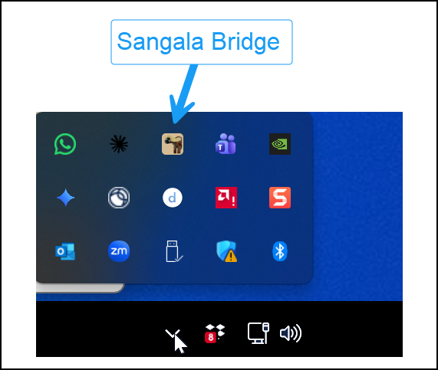
This bridge program manages the connection between Sangala Studio and a Silhouette digital die cutter if one is connected to the computer via a USB port.
- To place a desktop launcher on the desktop, double-click “Create Desktop Shortcut.cmd”.
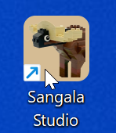
This icon can also be pinned to the task bar.
After downloading and installing the software, you can also download instructional resources that include a User Guide and a book, An Introduction to Design through Making.

Appendix B. Quick Reference

Tool | Action
Move or resize a shape | Select, then drag the shape or a corner
Label a shape | Right-click the shape, then type
Draw a rectangle or circle | Shapes, Rectangle or Circle, then drag
Draw a free-form outline | Pen, click each point, Enter to finish
Carry on from a loose end | Pen, click the end of the outline
Reshape an outline | Nodes, then drag, add, or delete points
Make a line fold instead of cut | Select it, click Fold
Join, subtract, or overlap two shapes | Combine, then Union, Difference, or Intersect (in 3D, Union or Intersect only)
Center one shape in another | Select both, Align, Center
Cut a subject out of a photo | Open the photo, Remove BG, Confirm
Crop a photo to a circle or shape | Draw the shape, then Combine, Intersect
Print, then cut on the print | Marks on, Print, Make It!
Rotate a shape | Select it, then drag the round handle above it
Nudge a shape a small distance | Select it, then press an arrow key (Shift for 1 mm)
Fill a shape with a paper color | Select it, then click a color in the Selected object panel
Change which shape is in front | Select it, then Back, Lower, Raise or Front
Undo or redo a change | Ctrl-Z undoes; Ctrl-Y redoes
Draw with Snap!'s turtle | Snap!, send pen trails to Sangala
Draw a straight line | Shapes, Line; Fold makes it a crease
Add a glue tab to a shape | Shapes, Tab, then drag along the shape's edge
Break a shape apart at a node | Nodes, click a node, Break at Node
Duplicate a shape | Ctrl-C copies; Ctrl-V pastes a copy
Mirror a shape or an assembly | Select it, Mirror, Flip Horizontal or Flip Vertical
Turn Snap to Fit on or off | The magnet button beside the zoom controls
Save a project that reopens exactly | Save, then Save project
Save an SVG for TinkerCAD or the die cutter | Save, then Save as SVG
Export an STL for 3D printing | Export STL (shown in 3D mode)
Cut a second or further window into a shape | Combine, Difference, again for each window
Mark a shape as a hole to carve (3D) | Select it, check Hole in its details
Turn a line into a 3D bar | Draw a line in 3D, check 3D bar in its details
Bundle pieces to move together (3D) | Select them, Group; Ungroup peels one level
Open a mosaic as 3D parts | Open, then choose a .mosaic file
Open a brick figure as 3D parts | Open, then choose a .block file
Place a ready-made LEGO part (3D) | Part, then Brick, Plate, Slope, Cone, and so on
Keep a dragged part on the stud grid | Snap to Studs (the grid button); Alt drags free
Hold a shape in view without printing it | Select it, check Guide in its details
Set the depth of several parts at once | Parts panel, type a Depth on the plane heading
Name a part or a plane | Double-click its name in the Parts panel
Move a part to another plane | Parts panel, type the plane's number in its Plane column
Leave a part out of the printed model | Parts panel, clear its Show box
Mirror a plane into a full figure | The mirror button on the plane heading
Work on a full LEGO baseplate | Settings, Page size — LEGO baseplate 32 x 32 studs
Mirror a part into a separated pair | Raise its Base before extruding; a part at Base 0 comes out solid

Appendix C. Tool Sequences for Specific Designs
- A Single Silhouette — Open a photo, Remove BG, Confirm, then cut. Tidy the outline with Simplify nodes or the Node editing tool.
- A Collage — Draw or trace each shape, use the Shapes and Pen tools, and Align to position them. Cut each shape separately on a different color of cardstock (for simple silhouettes) and place the cut-out shapes by hand to form a collage.
- A Shadowbox Frame — Draw a square and a circle with Shapes, use Align Center to place the window, add folding tabs, and set the fold lines to Fold so the die cutter cuts them as a dashed fold line instead of cutting all the way through.

Appendix D. Drawing with TurtleStitch
TurtleStitch is a version of Snap! designed for computer-controlled embroidery machines. Its turtle draws with a pen in the same way, so it is also widely used to design paper models, and those designs can come straight into Sangala Studio to be cut. Everything in Section 7 applies; only the way the drawing is captured differs.
- Open TurtleStitch from Sangala Studio. Click the Snap! button in the Tools Palette and choose TurtleStitch. It opens in a window of its own, with the Sangala blocks already loaded — look for a palette named Sangala Studio Tools. Open it this way every time. A TurtleStitch window opened from a bookmark arrives without the blocks and cannot send anything back, because two windows are only allowed to talk to one another when one of them opened the other.
- Enable JavaScript. In TurtleStitch’s settings menu (the gear icon), check the JavaScript extensions box. The blocks will not run without it.
- Import a TurtleStitch Project. Elaine Wolfe’s TurtleStitch site has many projects that can be cut out on a Silhouette Die cutter: https://turtlestitch.blogspot.com/search
You can identify TurtleStitch projects on her website designed for the Silhouette by entering that word as a search term. Projects like these will appear.
Open the project. Copy the project’s web address from the blog posting, choose Open a Project from the Snap! button in Sangala Studio, paste the address and press Open. The project opens with the Sangala blocks already in it, so the only thing left to do is add the send block to the end of the script.
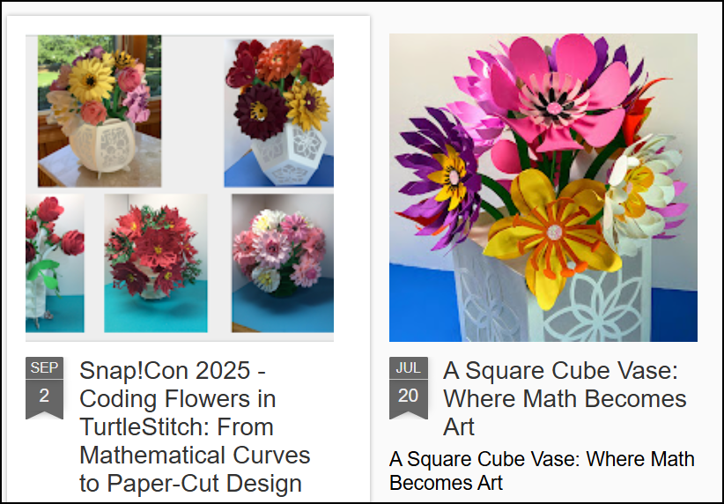
Figure 36. These sample projects from Elaine Wolfe’s TurtleStitch site can be used to create flowers.
- Send the drawing. Put the Send Paths to Sangala Studio block at the end of one of Elaine’s scripts and run it. TurtleStitch records every stroke as it draws, so Record Turtle Paths is not needed there — an existing TurtleStitch project needs no changes at all beyond adding the send block at the end. The completed drawing will appear in the workspace of Sangala Studio.
Troubleshooting Tip — If the blocks are missing. Sangala Studio sends them when it opens the editor, so this should not arise. If the palette is not there, choose Add Sangala Library from the Snap! button, which sends them again. Only if that fails, choose File, then Import in the editor, and select the file “Sangala for Snap.xml” from the folder Sangala Studio runs from.
If the browser asks permission. Chrome may ask whether turtlestitch.org may access other apps and services on this device. Choose Block. The two windows talk to each other directly and do not need it. If the question keeps coming back, the TurtleStitch window was not opened from the Snap! button, and nothing will arrive until it is.
What arrives. The pen color decides, exactly as it does in Section 7: a blue line becomes a fold line, and a line of any other color becomes a cut line. The design lands in the middle of the page and can be moved, resized, and combined like anything else drawn in Sangala Studio.
What size. A design arrives at the size it was drawn: one hundred and twenty-seven turtle steps make an inch. Many of these projects include a small square labeled “one inch”, which was there to rescale the design in other software. It is worth keeping until the design is on the mat, where selecting it shows its size and confirms the project imported correctly; it can then be deleted, along with its label, since both are cut lines like any other.

